RE: *Peter Dempsey v Advanced Connected Solutions et al., Case No: 2021-595, Supreme Court of the State of New York County of Schoharie*

Date of Crash: July 9, 2021

Date of Birth: *Peter Dempsey:* June 1, 1987 [34 years old at time of crash]

**Background Facts**

On July 9, 2021, at about 5:29 am Peter Dempsey was the unrestrained driver of a 2004 Pontiac Grand Am 4DR sedan that was cresting a hill on northbound Old Sharon Rd., near 739 Old Sharon Rd. and about .25 miles north of Tubbs Rd., Canajoharie, New York. On the opposite side of the hill was a Cable Care utility crew performing utility maintenance work. Their unoccupied 2017 Ford F-150, with an attached 2002 Rolling Star enclosed fiber optics splicing trailer occupied by Cory Goehrig, was parked, facing south, in the northbound lane of Old Sharon Rd. Parked behind the Rolling Star trailer was Cable Care’s unoccupied 2005 GMC C8C042 T40 bucket truck with attached wood cable spool that was facing north. In response to the vehicles ahead of him, Mr. Dempsey applied his brakes, but was not able to stop in time. The front of his Pontiac struck the front of the Ford, and the impact pushed the Ford and attached Rolling Star trailer rearwards resulting in the rear of the trailer impacting the rear of the bucket truck’s attached wood cable spool and support arm. There were no roadway signs or other devices indicating the work zone was present. The defense has claimed that the sole cause of Mr. Dempsey’s alleged injuries included, but were not limited to, his failure to use his seat belt and his reckless speed which was determined by their expert to be between 70.9 mph and 74.6 mph in a posted 55 mph speed zone. The images below depict the police diagram and the subject vehicles post-collision:

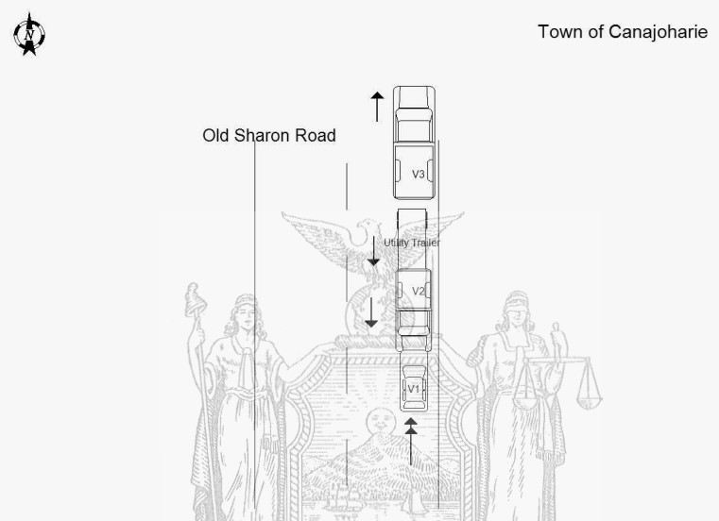

**Police diagram, Mr. Dempsey’s Pontiac is labeled “V1”**

**Crash scene, post-collision**

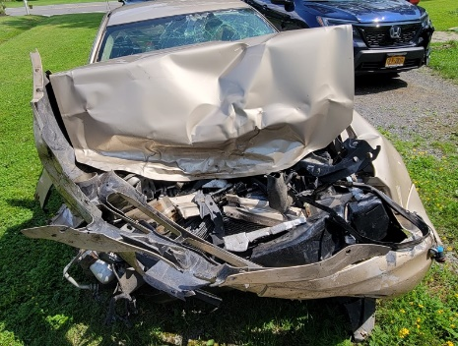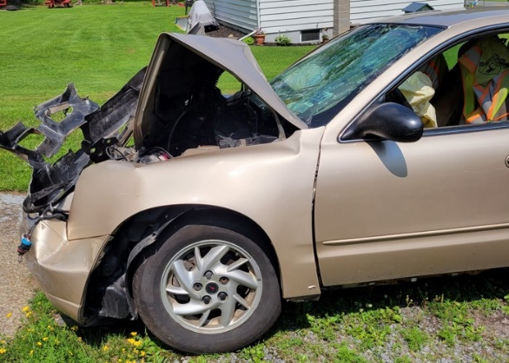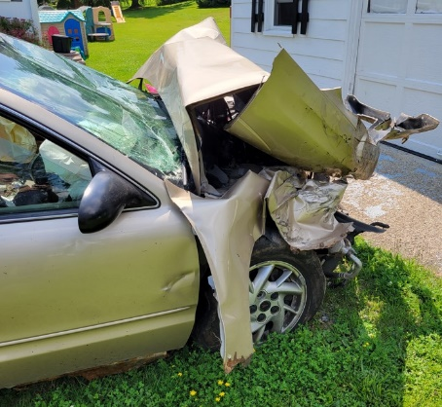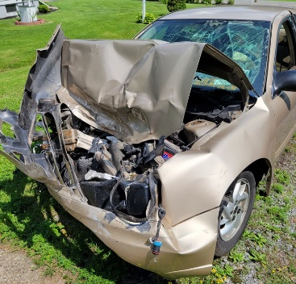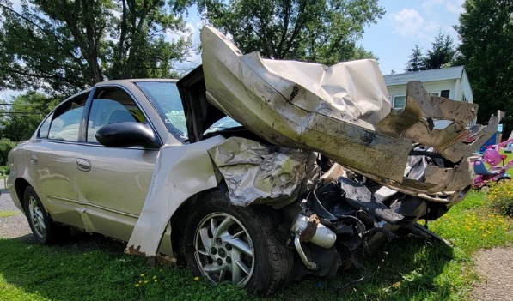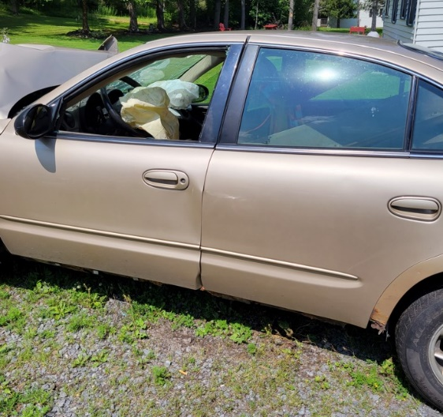

**Mr. Dempsey’s Pontiac, post-collision**

**Ford, post-collision**

**Ford-photos obtained from Mr. Harrington’s report**

**Rolling Star trailer, post-collision**

**GMC, post-collision**

No damage estimate was provided for the Pontiac for review. The provided photos showed damage to the front bumper system (bumper cover, fascia upper support, impact bar, reinforced beam), radiator, radiator support and other engine compartment items, front grille, both front lighting assemblies, hood, both front fenders, front windshield, driver’s and right front passenger doors, and the right rear passenger door. The Pontiac was towed from the scene, both frontal air bags had deployed, and it was later deemed a total loss.

No damage estimate was provided for the Ford for review. The provided photos showed damage to the front bumper, grille, both front lighting assemblies, hood, and the right front fender from the impact by the Pontiac and the rear bumper and trailer hitch receiver from the impact with the Rolling Star trailer tongue/hitch. The Ford was towed from the scene and no air bag deployment occurred.

No damage estimate was provided for the Rolling Star trailer for review. The provided photos showed damage to the rear door and left rear panel from contact with the rear cable spool and spool transport/support assembly of the GMC. The Rolling Star trailer was not towed from the scene due to damage.

No damage estimate was provided for the GMC for review. The provided photos showed damage to the cable spool and the spool transport/support assembly. The GMC was not towed from the scene and no air bag deployment occurred.

*Post-crash history*

Mr. Dempsey was on his way to work. He was unrestrained. On impact, airbags deployed, front and side. His right knee struck the dash, and his chest impacted the steering wheel. Mr. Dempsey was assisted (by bystanders/witnesses) out of his vehicle through the driver’s side window (the door would not open), although not aware of pain straight away, he was unable to stand due to a leg injury.

EMS responded by which time Mr. Dempsey had started getting pain in his right leg. On examination he had pain in his right hip, right knee, and right ankle. He was transported to the Albany Medical Center ED via ambulance. In the ED Mr. Dempsey complained of pain in his right ankle and right mid-thigh.

Due to the mechanism of Mr. Dempsey’s injuries, he was pan scanned. The scans revealed: comminuted fracture of the right acetabulum with extensive to the right ischial ramus; non-displaced right inferior pubis ramus fracture; moderately sized extraperitoneal hematoma over the right iliac vessels; mildly displaced left lateral first rib, and non-displaced 7 through 9 lateral rib fractures. Trauma and orthopedics were consulted, Mr. Dempsey was diagnosed with pelvic fracture, sciatic nerve palsy, fracture of the femur, and acetabular fracture. He had also sustained a right knee laceration (4 x 2) requiring sutures, and a skin tear to the posterior right elbow. He was admitted and prepped for the OR.

**Mr. Dempsey underwent an open reduction and internal fixation of the right acetabulum and calcaneus fractures, performed by Dr. Ernest Chisena (orthopedic trauma surgery).**

Mr. Dempsey underwent inpatient physical therapy and remained in hospital through July 15, 2021, when he was released home to self-care and orthopedic follow up. Mr. Dempsey was provided with prescriptions for Gabapentin 300mg, Tizanidine 4 mg, Oxycodone 5 mg, Acetaminophen 325 mg, crutches for ambulation, a neck collar and Ace bandage.

Post-surgery Mr. Dempsey had diminished sensation/paresthesias over his right lower extremity, weakness, and numbness; and he developed right foot drop with diminished tibial and peroneal nerve function.

Mr. Dempsey subsequently followed up with Dr. Chisena and Dr. Andrew Rosenbaum (orthopedic surgery) at the Bone & Joint Center.

On July 19, 2021, Mr. Dempsey presented to Dr. Jafojo Olayemi (family medicine). He was provided with a prescription for Percocet.

On September 20, 2021, Mr. Dempsey underwent electromyography/nerve conduction velocity (EMG/NCV) studies of the right lower extremity which revealed a right sciatic neuropathy with evidence of sensory and motor axon loss, right superior gluteal neuropathy with evidence of motor axon loss.

October 11, 2021, through January 2022, Mr. Dempsey underwent physical therapy.

On June 24, 2022, Dr. Andrew Rosenbaum (orthopedic surgery) discussed proceeding with a right ankle fusion as Mr. Dempsey was unable to tolerate foot bracing.

Mr. Dempsey progressed well following the right hip surgery; Dr. Chisena released him to follow up as needed on August 25, 2022.

**On December 7, 2022, Mr. Dempsey underwent right percutaneous tendo-Achilles lengthening and right ankle fusion, performed by Dr. Andrew Rosenbaum (orthopedic surgery).** Post-operative diagnosis included: right lower extremity foot drop post sciatic nerve injury and right lower extremity Achilles’ tendon contracture.

Post-ankle surgery Mr. Dempsey underwent therapy at ProActive Physical Therapy and treated twice a week through April 19, 2023. Height: 6 ft, weight: 209 lbs.

*Pre-crash medical history*

Mr. Dempsey was in a prior (side impact) traffic crash in 2019, without injury

He sustained a left collarbone fracture, age 8 years, with no residuals

Mr. Dempsey received chiropractic care for lower back strain in circa 2010

History of remote heroin abuse. Used Suboxone once/twice a week; started taking from age 28 years. Took it a couple of days prior to the subject crash.

**Documents reviewed**

Peter Dempsey, deposition May 12, 2023

Albany Medical Center Hospital ED

Greater Amsterdam EMS (GAVAC)

ProActive Physical Therapy

Bassett Healthcare

Adirondack Rehabilitation Medicine EMG/NCV studies

Bone & Joint Center, Drs Chisena and Rosenbaum

New York State Department of Motor Vehicles Police Accident Report/Montgomery County Sheriff’s Department

Montgomery County Sheriff Response to FOIL

5-body worn camera video files

Numerous digital color photos/images (Folders/files named-Montgomery Co. Crash Photos.pdf, Photos from BA, Photos from client, Photos from JP, Photos from RB)

Report from defense expert, Dr. Lewis Devine-ARCCA

Report from defense expert, Shawn Harrington-Forensic Rock

Report from defense expert, Dr. Cambareri

Report from defense expert, Dr. Petroski

Deposition (EBT) transcript of Patrick Dempsey (May 12, 2023)

Deposition (EBT) transcript of Keegan Kelleher (November 16, 2023)

Deposition (EBT) transcript of Michael Parzych (June 15, 2023)

Defendant’s Verified Bill of Particulars As To Affirmative Defenses

Signed statement from Em Kraak (March 29, 2023)

Signed statement from Eric Logan (March 17, 2023)

Signed statement from Frank Nestle (March 17, 2023)

Signed statement from Jon Ward (March 17, 2023)

Signed statement from Michael MaGinnis (May 1, 2023)

Signed statement from Nathan Haig (March 29, 2023)

Signed statement from Shawn Bowerman (March 29, 2023)

Signed statement from Anne Clouthier (March 16, 2023)

Signed statement from Bethany Alverson (May 17, 2023)

Typed statement from Keegan Kelleher (June 27, 2023)

GAVAC ambulance transport records

*Reconstruction:*

According to the police report it was dawn (limited lighting condition), cloudy and the roadway was dry. A review of the officer’s body worn camera footage showed the roadway to be a mixture of dry and damp conditions. The time stamp of the first on scene video was 5:42 am. The speed limit on Old Sharon Rd. was reportedly 55 mph.

Mr. Dempsey, deposed on May 12, 2023, testified that he was traveling northbound on Old Sharon Rd. at about 50-60 mph, his headlights were on as the sun was not yet up and he was not wearing his seat belt. He came over a steep hill and directly on the other side of it were the other vehicles that were suddenly there. There weren’t any signs, traffic cones, or any other warning that a work zone was ahead. He was about 40 feet away from the Ford when he first saw it and it was parked in his lane facing him. He thought he was going about 55 mph at that point, he only had time to get heavy on his brakes and he did not make any steering avoidance maneuvers. The front of his Pontiac struck the front of the Ford, the impact was extremely heavy and hard, and he thought his foot was still on the brake. He did not know if the any of the vehicles moved after the impact. The dashboard came into his knee, his chest probably hit the steering wheel and his airbags deployed.

Mr. Kelleher, deposed on November 16, 2023, testified that on the day of the subject crash he was a lineman for Cable Care, and he, Cory Goehrig and Ethan Achzet were sent to the location to splice some fiber optic cable. Cory drove the GMC bucket truck and Ethan drove the Ford pickup truck to the site. The Ford truck and trailer were parked facing north, uphill, and the GMC bucket truck was backed in right behind the trailer and was facing south, downhill. He did not think any portion of the Ford truck was in the travel lane and a tire on the attached trailer and the GMC bucket truck may have been slightly in the travel lane. Ethan had placed 2-3 traffic cones up and they were placed in front of the bucket truck’s drivers tire and the back tire of the trailer. They did not place any signs, traffic cones, or any other form of warning to traffic that there was a work zone ahead, which was required by Cable Care’s policies, since the area was so rural. The Ford truck was turned off and did not have any lights on or any other illumination, but the bucket truck had its hazard flashers on. The front of the Ford was about 30 feet from the top of the hill it was facing and there were no traffic cones between it and the top of the hill.

Immediately prior to the impact he heard tires screeching, which lasted for about 2-3 seconds. At the time the impact occurred Ethan was on the back driver’s side dually tire of the bucket truck standing on the roadway and it was his job to be the ground hand flagger. Cory was inside the splicing trailer, and he (Kelleher) was on the other side of the bucket truck in the grass. The weather at the time of the subject crash was dry and the lighting conditions were not fully light yet, described as blue grey.

None of the vehicles involved in the subject crash were moved after the impact was over, nor was the scene changed before law enforcement arrived other than placing some new traffic cones around the Pontiac.

In his typed statement dated July 27, 2023, he stated that the Ford was parked on the other side of a crest of a hill, on the right side of the road with part of it on the roadway and its flashers were on. They usually put signs up but did not do so in this case since the area was rural. They all heard the brakes lock up on the Pontiac and heard the crash but did not see it. He did not have any idea how fast the Pontiac was going. There had been some daylight that just started to show, it was overcast, and the roads were dry.

Mr. Parzych, deposed on June 15, 2023, testified that he was the president of the company and came out to the scene when he was notified of the crash. He spoke to the three workers involved and he was told that there were traffic cones set up from the front of the Ford up to the top of the hill. He did not recall if the cones were present or not when he arrived. He did not recall if any signage had been in place and there wasn’t a flagger at the top of the hill. The on-scene Deputy told him that traffic cones were in place when law enforcement arrived, and Mr. Dempsey would be receiving a fistful of tickets.

No depositions or other formal statements from Mr. Achzet or Mr. Goehrig were provided for review.

Ms. Clouthier, in a signed statement dated March 16, 2023, stated she responded to the scene in her personal vehicle as a member of the Canajoharie Volunteer Fire Department. She approached the scene from the north, it was daybreak, the road conditions were dry, it was not raining, and she did not see any signs, traffic cones, or any other warning to drivers of the work zone. She also did not remember seeing any on the south side of the work zone either.

Ms. Alverson, in a signed statement dated May 17, 2023, stated she was Mr. Dempsey’s fiancé, and she went to the scene after he called her and told her about the crash. She parked her car at the south side of the scene. She did not see any warning signs placed to alert drivers of the work zone. She checked the north side of the scene and did not see any warning signs or traffic cones there either.

Mr. Kraak, in a signed statement dated March 29, 2023, stated that he responded to the crash scene as a member of GAVAC and was the driver of the ambulance. They approached the scene from the north, and he did not remember seeing any signage or cones in the roadway alerting traffic of the work zone.

Mr. Logan, in a signed statement dated March 17, 2023, stated that he responded to the crash scene as a member of the Canajoharie Fire Department, and they approached the scene from the north. He did not see any traffic cones, flaggers, or signage that alerted traffic of the work zone.

Mr. Nestle, in a signed statement dated March 17, 2023, stated that he was the Chief of the Canajoharie Fire Department and he responded to the scene of the subject crash. They approached from the north side of the scene, and he did not see any traffic cones, signs, or flaggers warning drivers of the work zone. He did not see any on the south side of the crash scene either.

Mr. Ward, in a signed statement dated March 17, 2023, stated that he was the Second Assistant Chief with the Canajoharie Fire Department and he responded to the scene of the subject crash. They approached from the north side, and he did not see any traffic cones, signs, or flaggers warning drivers of the work zone. Mr. Dempsey told him he was going about 55 to 60 mph before he saw the vehicles in the road, but it was too late.

Deputy MaGinnis, in a signed statement dated May 1, 2023, stated that he arrived at the scene at about 5:41 am and approached it from the north end. He drove through the scene and parked his patrol vehicle on the south end. He did not see any traffic cones, signs, or flaggers warning drivers of the work zone at either end of the work zone.

Mr. Haig, in a signed statement dated March 29, 2023, stated that he was the First Assistant Chief of the AMES Volunteer Fire Department and he responded to the scene of the subject crash in his personal vehicle and approached it from the north. He did not see any traffic cones, signs, or flaggers warning drivers of the work zone. He never visualized the south end of the work zone and did not know if there were any signs there or not. He thought the weather was clear and the roads were dry.

Ms. Bowerman, in a signed statement dated March 29, 2023, stated that she was the Chief of the AMES Volunteer Fire Department and she responded to the scene of the subject crash. They approached the scene from the south end, and she did not see any traffic cones, signs, or flaggers warning drivers of the work zone. She thought it was overcast, not raining, and the roads were dry when she arrived.

Video surveillance

The videos were taken from a deputy’s front facing body worn camera and there were 5 video files. The earliest video footage was date/time stamped at 05:42:44 am on July 9, 2021. The deputy was walking north in the northbound lane of Old Sharon Rd. after the crest of the hill towards the crash scene. The braking tires marks left by the Pontiac were seen in the northbound lane. The skies were overcast with light and dark clouds. The roadway was seen to be mostly light in color with some dark patches that could have indicated dampness on its surface. As the deputy neared the crash scene the roadway was completely dark indicating it was likely damp. Just beyond the front of the GMC bucket truck the roadway was again in a condition of light and dark patchiness in appearance.

**BWC video footage**

EDR download data-Ford

No CDR report was provided for review. Mr. Harrington discussed it in his provided report, and it was apparently imaged on October 11, 2022, during his inspection of the Ford.

* The ignition cycle at the crash event was 4,210.
* The ignition cycle at imaging was 4,212.
* The recorded events (a locked frontal event and a fuel cutoff event) were related to the subject crash.
* The -5 seconds to 0 seconds pre-crash data indicated that
  + The Ford was stopped, in park, the service brake was off, and the engine RPM was between 564 and 606 rpm.
* The longitudinal delta V was -14.34
* The lateral delta V was approximately -1 to -2 mph.
* No other pertinent data was listed in his report.

**Opinions of defendant’s expert, Dr. Cambareri**

Dr. Cambareri performed a CME (listed as an Independent Orthopedic Evaluation/IME) on Mr. Dempsey on August 15, 2023, and documented his findings in a 13-page report dated October 12, 2023. He concluded that as a result of an injury that occurred on July 9, 2021, that Mr. Dempsey sustained a complex fracture of his right acetabulum with an associated sciatic nerve palsy that resulted in a permanent right foot drop. There was evidence that Mr. Dempsey did not have any motion in the right ankle joint and had diminished motion in the right subtalar joint. Mr. Dempsey’s intermittent groin pain was also consistent with the objective findings. There were no comorbidities that would have a factor in Mr. Dempsey’s orthopedic condition.

**Opinions of defendant’s expert, Dr. Petroski**

Dr. Petroski performed a CME (listed as an Independent Orthopedic Examination/IME) on Mr. Dempsey on March 29, 2023, and documented his findings in a 14-page report dated April 6, 2023. He concluded that the subject crash was casually related to Mr. Dempsey’s injuries (right knee contusion/laceration, right acetabular fracture, right sciatic nerve traumatic neuropraxia with foot drop, right os calcis fracture, left 1st rib fracture, right 7th, 8th, and 9th rib fractures).

**Opinions of defendant’s expert, Dr. Lewis Devine (ARCCA)**

Dr. Lewis Devine provided an 11-page report dated February 14, 2024, that contained her opinion that Mr. Dempsey’s injuries (right acetabular and posterior pelvic wall fractures with associated sciatic nerve injury, right calcaneus fractures) would not have occurred, or would have been lessened, had he been wearing his available three-point safety restraint.

Dr. Lewis Devine’s substantive conclusions can be summarized as follows:

* The delta V of the subject Pontiac was between 32 mph and 38 mph.
* Mr. Dempsey experienced blunt impact and compressive loading to his right knee and femur due to his uncontrolled forward motion during the impact with the Ford. The loading potential through his right femur would have been significantly reduced or eliminated had he been using his restraint system.
* Mr. Dempsey experienced axial compressive loading to his right foot against the brake pedal due to his uncontrolled forward motion during the impact with the Ford. The loading potential to the right calcaneus would have been significantly reduced or eliminated had he been using his restraint system.
* She cited 39 studies/publications in her report.

**Opinions of defendant’s expert, Mr. Harrington (Forensic Rock)**

Mr. Harrington provided a 33-page report dated February 16, 2024, that contained his opinion that had Mr. Dempsey been traveling at, or just below the posted speed limit, that the subject crash would not have occurred, and his speed was a contributing factor to the subject crash.

Mr. Harrington’s substantive conclusions can be summarized as follows:

* The longitudinal delta V of the parked and idling Ford F-150 (per the RCM) was -14.34 mph, and the lateral delta V was approximately -1 mph to -2 mph.
* The longitudinal delta V of the Pontiac (based on a conservation of momentum equation) was approximately -43.8 mph.
* Using VCRASH, the delta V of the Ford was -13.7 mph and delta V of the Pontiac was -41.9 mph.
* The BEV for the Pontiac was approximately 37.2 mph to 39.4 mph (using a restitution of 10% to 15%).
* The impact speed of the Pontiac was approximately 49.4 mph to 52.3 mph.
* The speed of the Pontiac at the beginning of the braking tire marks (measured between 120 and 129 feet) was between 70.9 mph and 74.6 mph (see Table 1 below). This was calculated with 10% to 15% restitution. If restitution was ignored, the speed would be approximately between 75 – 80 mph.
* Hot shock was seen to the right front hazard light bulb on the GMC bucket truck indicating it the hazard lights were on at the time of the impact.
* Mr. Dempsey likely perceived, reacted and initiated a mechanical response of his vehicle in less than 1 second.
* Mr. Dempsey more likely than not applied his brakes within approximately 0.5 seconds of the Ford first becoming visible to him. The speed of his vehicle prior to braking contributed to the severity of the subject crash and prevented him from being able to stop in time to avoid the impact.
* Two alternate analyses were conducted in VCRASH to evaluate the Pontiac at loser speeds.
  + Modeled at a 55-mph pre-braking speed (rather than 72.75 mph)
    - The delta V would have been 27.1 mph less than that which actually occurred.
    - The Pontiac’s impact speed would have been approximately 16 – 20 mph.
  + Modeled at 52 mph pre-braking speed (rather than 72.75 mph) with the same perception-reaction-time concluded in the subject crash
    - The collision would have been avoided altogether.
  + See Tables 2 and 3
* He utilized the following in his calculations
  + 4.5% to 4.8% downhill grade of the roadway
  + A range of friction coefficients for clean, dry asphalt of 0.7 to 0.85 with the average being 0.775.
  + The drag factor, after accounting for the roadway grade, was 0.72 to 0.73.
  + It did not appear that he determined if the Pontiac’s braking tire marks were from the front tires, rear tires, or both and his calculations were for 100% braking. It also did not appear that he adjusted the roadway drag factor for the likely dampness of the roadway or the amount of braking/sliding v rolling friction of the tires if the braking was not 100%.

**Tables from Mr. Harrington’s report**

*Crash Analysis:*

The EDR download of the Ford can be used in a simulation to determine impact speed. Using a widely used crash simulation program[1] can estimate an approximate speed change or delta V imparted to the Ford and Pontiac in the crash, using a momentum, energy and restitution (MER) analysis.

A closing speed of approximately 30 mph from the Pontiac would have resulted in a delta V in the Ford of approximately 14.4 mph. This is fairly consistent with the EDR data in the Ford and confirmed with an accelerometer placed between the front seats on the floorboard of the Ford model (approximately where the actual airbag module is). Delta V in the Pontiac is approximately 20.0 mph with a peak acceleration of approximately 14.6 g.

Mr. Harrington used a hand calculated momentum equation to obtain an impact speed of 49.4 – 52.3 mph. His calculation is based on the total mass of the Ford and the attached trailer however the trailer is connected by an articulating pintle ring that buckled and eventually bent during the collision. The error in using his momentum equation is that it considers the entire mass of the trailer and Ford as a single point or single mass. This overstates the impact forces between the Ford and the Pontiac which is why there is such a large disparity between his calculation and the simulation.

He further compounds his errors by overstating the roadway friction as 0.775 g. It is noticeable in the photos that the pavement is either wet or damp and he does not account for this in his estimation of the roadway friction. I have tested roadway friction by various means (vehicle slide to stop, accelerometers and drag sleds as well as dragging vehicles with a weigh scale) and found that most well used roadways are typically 0.65 to 0.68 g. Additionally, there is only tire marks from what is likely the front tires of the Pontiac and no tire marks from the rear tires indicating that the rear tires were not 100% effective; Mr. Harrington does not account for this either.

Based on the simulation impact speed of approximately 30 mph, and accounting for an average 4% downslope then the range of roadway friction should be around 0.61 to 0.64 g. If I allow for 100% braking efficiency and 129 feet of tire marks, then this would indicate his maximum speed when the Pontiac began leaving tire marks was approximately 57 to 58 mph. Considering the damp roadway and less than 100% braking efficiency the Pontiac’s speed would have been slower than 58 mph.

1. Virtual Crash 5, vCrash America Inc.